SUSTAINABLE FASHION WEBSITE

# INDEX

|  |  |  |
| --- | --- | --- |
| 1 | ABSTRACT | 3 |
| 2 | INTRODUCTION | 4 |
| 3 | SCOPE | 5 |
| 4 | CLASS AND ER DIAGRAM | 6-8 |
| 5 | SCREENSHOT | 9-11 |
| 6 | CONCLUSION AND FUTURE SCOPE | 12 |

**ABSTRACT**

A sustainable fashion website represents a transformative digital ecosystem, redefining the fashion industry's landscape. This online platform is a beacon for environmentally conscious consumers, offering an extensive range of clothing, accessories, and footwear that embody both style and sustainability. Curated with utmost care, the website features products exclusively from brands committed to ethical production processes, fair labor standards, and eco-friendly materials. Users can navigate through a diverse collection, guided by detailed sustainability metrics, such as sourcing origins, carbon footprint, and certifications, empowering them to make choices that align with their values.

Moreover, the sustainable fashion website transcends commerce. It serves as a beacon of education and advocacy, delivering invaluable insights into sustainable fashion practices through articles, videos, and community forums.

Users not only shop consciously but also actively participate in discussions, share experiences, and collaborate to foster a fashion industry with a reduced environmental footprint and enhanced social responsibility.

# INTRODUCTION

The fashion industry is constantly growing, but it also causes serious environmental problems such as pollution, waste, and the use of non-eco-friendly materials. **Sustainable fashion** is a modern approach that focuses on creating clothes in ways that are kind to the planet and fair to the people who make them.

A **Sustainable Fashion Website** is designed to spread awareness about eco-friendly clothing, promote ethical brands, and encourage people to make responsible fashion choices. It provides information on sustainable fabrics, recycling old clothes, and reducing fashion waste.

The main aim of this website is to inspire users to adopt a greener lifestyle by choosing fashion that not only looks good but also helps protect the environment for future generations.

# Scope

The scope of the substainable fashion project involves:

* **Information Dissemination:** Provide comprehensive resources on sustainable fashion, including articles, guides, and tools.
* **Product Platform:** Offer a marketplace for eco-friendly and ethically- produced fashion items.
* **Community Building:** Foster a community of individuals passionate about sustainable fashion.
* **Collaboration Hub:** Connect with like-minded brands, organizations, and influencers in the sustainable fashion space.

**Advocacy Platform:** Raise awareness about critical issues in the fashion industry and support initiatives for positive change

CLASS DIAGRAM:

Class diagram is a static diagram. It represents the static view of an application. Class diagram is not only used for visualizing, describing, and documenting various aspects of a system but also for constructing executable code of the software application.

Class diagram describes the attributes and operations of a class and also the constraints imposed on the system. The class diagrams are widely used in the modelling of object-oriented systems because they are the only UML

diagrams, which can be mapped directly with objectoriented languages.

Class diagram shows a collection of classes, interfaces, associations, collaborations, and constraints. It is also

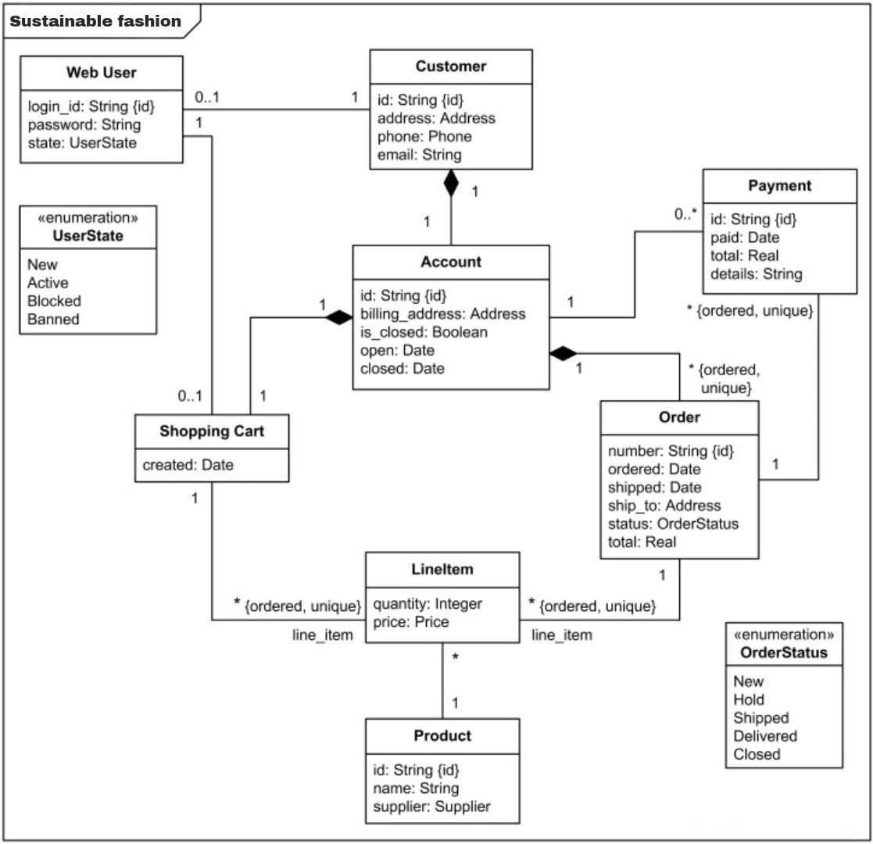

# E-R Diagram:

* What is ER Model?
* ER Model stands for Entity Relationship Model is a high-level conceptual data model diagram. ER model helps to systematically analysis data requirements to produce a well-designed database. The ER Model represents real-world entities and the relationships between them. Creating an ER Model in DBMS is considered as a best practice before implementing your database.

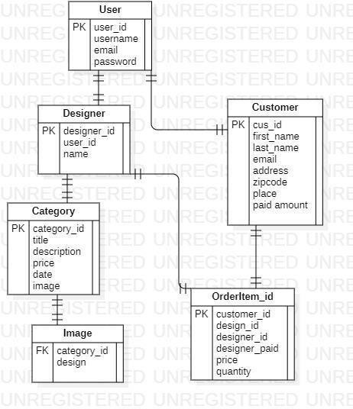

# SCREENSHOT :

**HOME PAGE:**

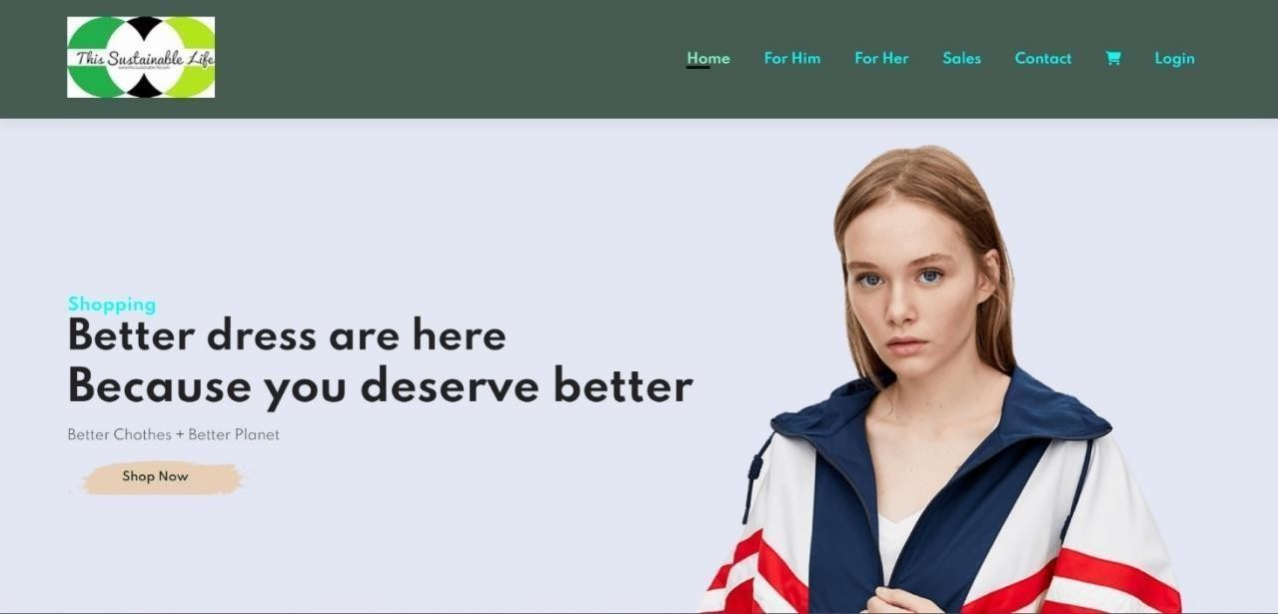

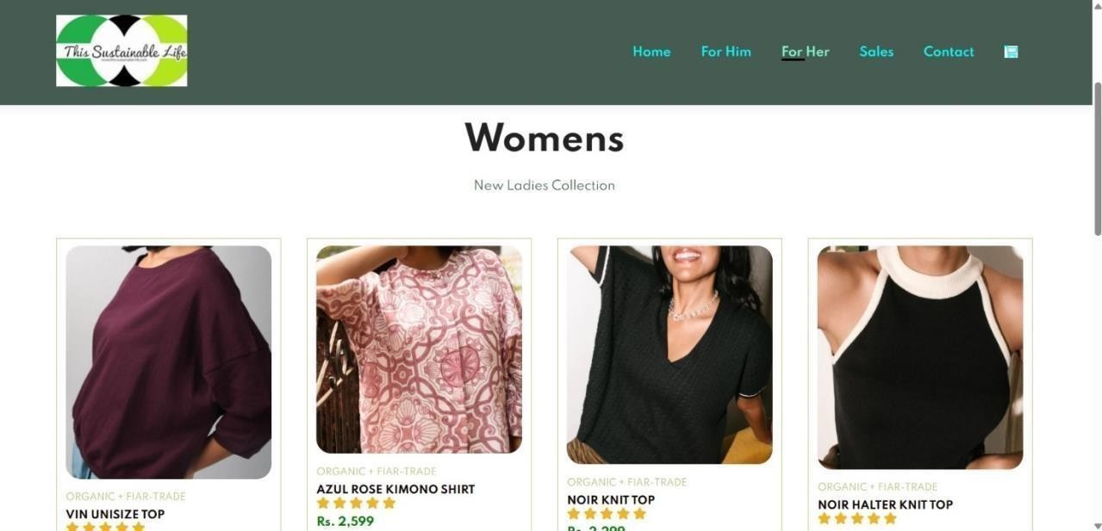

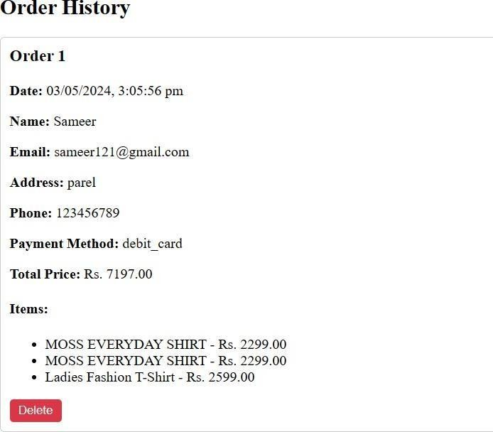

**CONCLUSION AND FUTURE WORK**

In conclusion, the creation of this sustainable fashion website stands as a testament to the power of technology in advancing eco-conscious initiatives. By harnessing the capabilities of HTML, CSS, and JavaScript within the framework of a WordPress template, I've crafted a digital platform that not only showcases stylish and sustainable fashion but also embodies its principles through thoughtful design and functionality. From the meticulously structured HTML elements to the visually captivating CSS styles and dynamic JavaScript interactions, every aspect of the website has been carefully orchestrated to deliver a

seamless and engaging user experience.

As society increasingly gravitates towards more sustainable lifestyles, this website serves as a beacon, inspiring individuals to embrace fashion choices that are not only

aesthetically pleasing but also environmentally and socially responsible. Beyond mere presentation, the website aims to foster a community of like-minded individuals passionate about sustainability, offering resources, insights, and interactive features to empower users on their journey towards conscious consumption. In essence, this

sustainable fashion website represents a digital embodiment of the values it espouses – innovation, inclusivity, and a commitment to a greener future.



References:

<https://www.fashionrevolution.org/>

<https://apparelcoalition.org/>

<https://www.globalfashionagenda.com/>

<https://www.ellenmacarthurfoundation.org/>